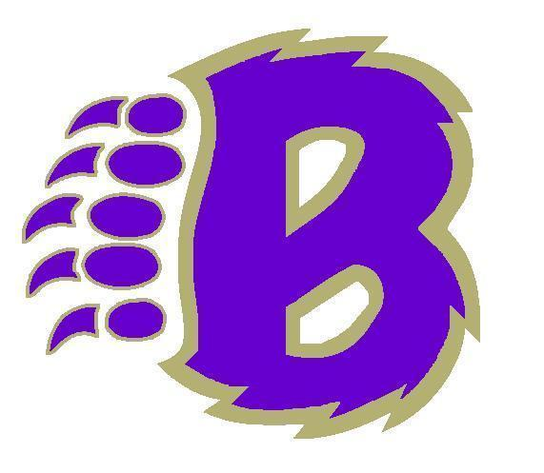

**2024-2025 BRIGGS HIGH SCHOOL STUDENT HANDBOOK**

**PRINCIPAL MESSAGE**

We welcome ALL of you to our Briggs Bruin family! At Briggs, we work hard to make sure that all students feel a sense of belonging when they walk into our building and our classrooms. We are excited to continue our Bruin STRONG values and PBIS program which highlights and celebrates many of the amazing characteristics of our students here at Briggs.

**Briggs Vision:** Cultivating Learners and Leaders

**Briggs Mission:** To empower students to succeed and reach their goals.

**BRIGGS HS CORE VALUES: WE ARE BRUIN S.T.R.O.N.G.**

To accomplish the Briggs Mission the staff and students will focus on being **Bruin S.T.R.O.N.G.** We believe that when these core values are demonstrated throughout the school it creates a positive learning environment for all and builds a strong sense of community.

**S = Support One Another T = Trustworthy R = Respectful O = Open Minded N = Never Give Up G = Growth Focused**

**WE ARE BRUIN S.T.R.O.N.G. DURING AN ASSEMBLY**

**S** – We **Support One Another** by entering the assembly in an orderly and quiet manner and move with our class to our assigned area.

**T** – We are **Trustworthy** by sitting in our assigned areas and listening to our teacher’s instructions and the instructions of the presenter.

**R** – We are **Respectful** by listening attentively to the presenter, not talking during the presentation, and engaging in appropriate responses.

**O**- We are **Open Minded** by listening and being respectful to the presenter even if I disagree with what they are saying.

**N** – We **Never Give Up** by staying attentive throughout the entire presentation.

**G** – We are **Growth Minded** by considering how the information being presented can apply to our own lives and help us grow.

**WE ARE BRUIN S.T.R.O.N.G. IN THE HALLWAYS**

**S** – We **Support One Another** by staying to the right of the hallway/stairwell and helping each other get to class on time.

**T** – We are **Trustworthy** by following school rules even when no one is looking (i.e. headphones).

**R** – We are **Respectful** by using positive language not using profanity or insulting people.

**O**- We are **Open Minded** by being friendly to people even if we don’t know them.

**N** – We **Never Give Up** by continuing to move to class and not stopping in the hallway which blocks the flow.

**G** – We are **Growth Minded** by responding positively to interactions with others.

**WE ARE BRUIN S.T.R.O.N.G. IN THE CLASSROOM**

**S** – We **Support One Another** by working collaboratively with peers and with the teachers.

**T** – We are **Trustworthy** by respecting people’s personal space and personal items.

**R** – We are **Respectful** by honoring a reasonable teacher’s request in a reasonable amount of time.

**O**- We are **Open Minded** by accepting other people’s ideas without judgment.

**N** – We **Never Give Up** when the work gets hard.

**G** – We are **Growth Minded** by learning from our mistakes.

**WE ARE BRUIN S.T.R.O.N.G. IN THE CAFETERIA**

**S** – We **Support One Another** by lining up in the lunch line in an orderly manner.

**T** – We are **Trustworthy** by respecting people’s personal space and personal items.

**R** – We are **Respectful** by cleaning up after ourselves.

**O**- We are **Open Minded** by appreciating food that is different from what we typically eat.

**N** – We **Never Give Up** by remaining calm throughout the entire lunchtime.

**G** – We are **Growth Minded** by meeting new people and welcoming others to our table.

**REGULAR BELL SCHEDULE**

First bell 7:18 AM (students move toward classes and **exit** the cafeteria / halls)

Warning bell 7:25 AM (Students should all be heading to / in class)

PERIOD 1 7:30 - 8:19 AM

PERIOD 2 8:23 - 9:12 AM

PERIOD 3 9:16 – 10:06 AM

PERIOD 4 CLASS 10:09 – 10:58 AM

9TH GRADE FOCUS /12TH GRADE LUNCH 10:09-10:32 AM *Bell at 10:30 = 12th grade to FOCUS; Bell at 10:32 = 9th grade to lunch*

9TH GRADE LUNCH / 12TH GRADE FOCUS 10:32-10:58 AM

PERIOD 5 11:02 – 11:51 AM

PERIOD 6 CLASS 11:55 – 12:44 PM

10TH GRADE FOCUS /11TH GRADE LUNCH 11:55-12:17 PM  *11th grade to FOCUS; Bell at 12:18 = 10th grade to lunch*

10TH GRADE LUNCH / 11TH GRADE FOCUS 12:17-12:45 AM

PERIOD 7 12:48 – 1:37 PM

PERIOD 8 1:41 – 2:30 PM

**GRADUATION REQUIREMENTS**

Freshmen to Seniors Diploma of Graduation Diploma of Distinction

English 4 4

Math 4 4

Science 3  4 (Must include Chemistry or Physics)

Social Studies 3 4

P.E. 0.5 0.5

Health 0.5 0.5

Foreign Language  *-*  3 *same language*

Fine Arts 1 1

Technology 1 1

Internship 1 1

General Electives 3 1

Academic Elective 1 (extra Soc. Stud. or science)____________________

Totals Credits (22 cr.) Credits (24 cr.)

*Special Note: 120 hours of internship, which begins in the freshmen year, is required for all graduating seniors*

**PATHWAYS TO GRADUATION:**



**REQUIRED CREDITS FOR MATRICULATION:**  10th grade status: 5 Credits (4 core), 11th grade status: 10 credits (8 core), Senior status 15 credits (12 core). Core courses = English, math, social studies, science, P.E, health, academic elective, or technology credit

**GRADE POINT AVERAGE (G.P.A.)**

G.P.A. is figured by multiplying the academic credit earned for each subject by the numerical value of the grade: A = 4, B = 3, C = 2, D = 1, and F = 0. These are then totaled and divided by the total number of credits. Advanced Placement courses (AP) and Honors classes are weighted. Honor Roll is 3.0 and higher; Super Honor Roll is 3.5 and higher. Columbus City Schools is on the plus (+) minus (-) grading system. The senior with the highest GPA is considered the class Valedictorian and the second highest GPA is the class Salutatorian. Valedictorian and Salutatorian are determined after Fall Semester so that this can be reflected on transcripts for colleges and college applications.

**GUIDE TO STUDENT SUCCESS / POSITIVE STUDENT BEHAVIOR**

[The 2024-25 Student Guide to Success is now available](https://www.ccsoh.us//cms/lib/OH01913306/Centricity/Domain/4283/23-24%20CCS%20Guide%20to%20Student%20Success.pdf). The publication contains important documents that must be filled out and returned to your student's school of attendance OR completed as part of the [Parent Portal Annual Update (preferred method) in Infinite Campus](https://www.ccsoh.us/domain/188). The Annual Update can be accessed in the Parent Portal by first clicking on “More” and then “Annual Update." If your scholar has a form on file and he or she is remaining at the same school this year, a new form will not have to be submitted. If your scholar has changed schools or matriculated to a new school, a new form must be submitted. Separate forms must be on file for each individual student.

**DRESS CODE AND SCHOOL SAFETY**

We are charged with preparing students for college and careers. This dress code aligns with this goal in that it prepares students to understand the level of dress expected in these areas. Students out of dress code can expect teachers to notify administration, and the student will be assigned ISS until a parent can bring in the appropriate dress. **Some** highlighted areas of the CCS dress code are:

* Students must be appropriately covered at all times = No bare midriffs or shirts/dresses with straps thinner than 2 fingers in width.
* No halter/tube tops or dresses.
* No sleepwear or blankets / No Gang related apparel/No t-shirts with drug or sexualized images or statements are permitted.
* Hoodies, hat**s, bonnets, ski masks**  are not to be worn inside the building. If this becomes problematic a locker will be issued and these itemes will remain in a locker during school hours.
* Shorts and skirts should be mid- thigh length. “Biker shorts” and tight spandex dresses are not permitted.
* No sagging pants, pants with chains or spikes on belts or spikes worn as jewelry, or rips near the hip area.

**The full CCS dress code can be found at:** [**https://tinyurl.com/8at5jwbe**](https://tinyurl.com/8at5jwbe)

* Threats to students and staff will be taken seriously. Fighting, “play”fighting and joking about violence will be dealt with to ensure everybody is safe.

Safety is everyone's responsibility. Per CCS guidelines, metal detectors are in place and ALL students and visitors that enter the school will go through the metal detector / screening process and are subject to a search and /or wanding. These procedures are for everyone's safety.

**ATTENDANCE**

We know that students who attend school regularly and miss very few days tend to be academically successful and have a greater likelihood to graduate and have more college and career options than students with poor attendance. **We are an in person school**.Briggs is not a remote learning school.

[Link for CCS attendance AND HB410 OHIO STATE LAW](https://docs.google.com/document/d/1a88Ow0MbsP0clNYGMB-tDTdbd8MUWxAcWLeD6MDa5Jg/edit?usp=sharing) OR SEE PAGE 15 in our Guide to Student success

**Absences**

When it is necessary for you to miss school, the attendance office should be called between 7:00 - 8:30 a.m. at 365- 5639 on the date of the absence. You **MUST** bring a written note from the parent/ guardian stating the reason for the absence within 48 hours of the absence. Excused absences are:personal illness or quarantine, illness or death in the immediate family, Dr. appointment, college or career visit, court dates. Any other reason is subject to approval of the principal or designee. Each student is permitted 9 such accepted absences per school year. See Board Policy 5200

**Make-up Work**

Following an absence it is the students’ responsibility to check with each teacher regarding make-up work. Students will normally have an amount of time equal to the amount of time they have been absent to complete make-up work. Failure to do so or make special arrangements with the teacher will result in all work that has not been completed being counted as failing grades..

**Tardiness**

Being on time for school, and for class is an important life skill and critical for LEARNING. Tardiness to class and school is not acceptable. Habitual tardiness (5 times in a quarter) will be assigned an In School Suspension for the day. When students arrive tardy to school (after 7:30 am) they will sign in at the attendance table to receive a tardy slip.  HB410 law considers the number of minutes a student is present in school so arriving tardy to school also counts toward unexcused absences. **Students leaving early or arriving after 10:00 must have a note or be accompanied by a guardian. Students may not sign themselves out of school, even if they are 18.**

**CCS Board Policy 5410**:

In grades 9-12, a student will not receive credit in a course if s/he has been truant more than ten percent (10%) of the required attendance days, unless the Principal and the teacher agree that the student is academically prepared to receive credit.

**GUIDANCE COUNSELORS**

The guidance staff at Briggs High is here to assist students and parents. Counselor’s help students plan their course of study, schedule the appropriate classes, and assist with career planning. The counselors are not trained to treat psychological or emotional disorders, but are available to discuss personal problems and to assist, when possible, in resolving problems. In some cases, the best method of intervention is referral to an outside agency.

**TEXTBOOKS / CHROMEBOOKS**

Fees will be assessed for lost or damaged textbooks and Chromebooks. All fees must be paid in order to participate in graduation (additional restrictions may be applied). See librarian for questions. Students should bring their Chromebooks to school everyday.

**DRILLS**

All students should know where to go during a fire, tornado or emergency crisis drill. Each teacher will discuss these procedures with you the first week of school. A yellow card and map placed on the wall near the door will also tell students of these procedures. When a drill is in progress, no talking is permitted. You are to leave the room and proceed to your station in an orderly manner. Listen to your teacher or administrator and follow directions. These drills are serious business and your cooperation could save your life in an emergency.

**FIRE DRILLS “Fire! Fire!”**

When the alarm sounds, students should evacuate the building in an orderly, quiet manner and follow the direction of those in charge. Everyone is to stand 100ft away from the building, driveway or sidewalks, line up and remain quiet.

**TORNADO DRILLS “Be prepared!”**

When a special bell tone is sounded to identify the threat of a tornado, students should move quickly and quietly to an interior hallway (away from any glass) to be seated facing the walls in a row, double rows if necessary.

**LOCKDOWN DRILLS**

We are always under a level 1 lockdown. Follow the teacher's / staff direction if we go under a level 2 or 3 lockdown.

**ELECTRONIC DEVICES**

Teachers often have students use electronic devices during classroom instruction. Our goal is to teach our students responsible cell phone usage so that these skills will transfer to other professional settings (work, college, etc.). Teachers will provide clear instructions when it is appropriate for students to use their cell phones. Students may also use their cell phones responsibly during their lunch period.

**HALL PASSES**

Each student is required to have a pass if he/ she is in the halls when classes are in session. Hall passes must have the name, time, date & destination and teacher signature. Students will have a limited number of hall passes per class. Students are expected to use the restroom facilities between classes (unless it becomes necessary to temporarily close the rest rooms) and at lunch. **Closing the restrooms may occur if students are hanging out in them or they need repairs. Appointments with administrators, counselors or teaching personnel must take place during lunch or FOCUS time.** If a medical condition necessitates frequent restroom use, a note from a doctor must be on file with the nurse, so that staff can be appropriately notified and prepared. **No hall passes will be issued the first and last 10 minutes of class as well as after 2:00PM**. **Hall pass privileges can be revoked by the administration if a student abuses the privilege.**

**LOCKERS**

Lockers are the property of the school, loaned to students for their convenience and should be secured at all times. Students may **not** place supplemental locks on hall lockers. Students must understand that the administration has the legal right to inspect lockers if deemed necessary. Fill out a locker request form in the main office to request a locker.

**NON-CLASSROOM BASED SCHOOL SUPPORT STAFF**

Head Principal – Mrs Smith Head Custodian - Mr. Davis

Assistant Principal – 9th Grade – Dr.. Al-Sharafi Counselor – 9th Grade Williams

**11th A- G** Counselor – 10th Grade Emberger

Assistant Principal – 10th Grade - Mrs Patterson Counselor – 11th Mr. Jones **11th H-O**  Counselor - 12th Mr. Lawrence

Assistant Principal – 12th Grade – Dr. Higgins Head Secretary – Ms. Reavish

**11th P-Z**  Attendance – Ms. Sharf

Safety & Security - Mr. Person, Mr. Jones, Ms Wooden School Treasurer - Mrs. Diserio Nurse - Nurse Bragg Student Records - Ms. Skaggs

Athletic Director – Mr. Cam Pangallo Cafeteria Manager - Mr.Garcia

Student Support Center – Mrs. Saunders Librarian - Munnerlyn

School Social Worker – Ms. Peters Internship Coordinator - Mrs. Diawara

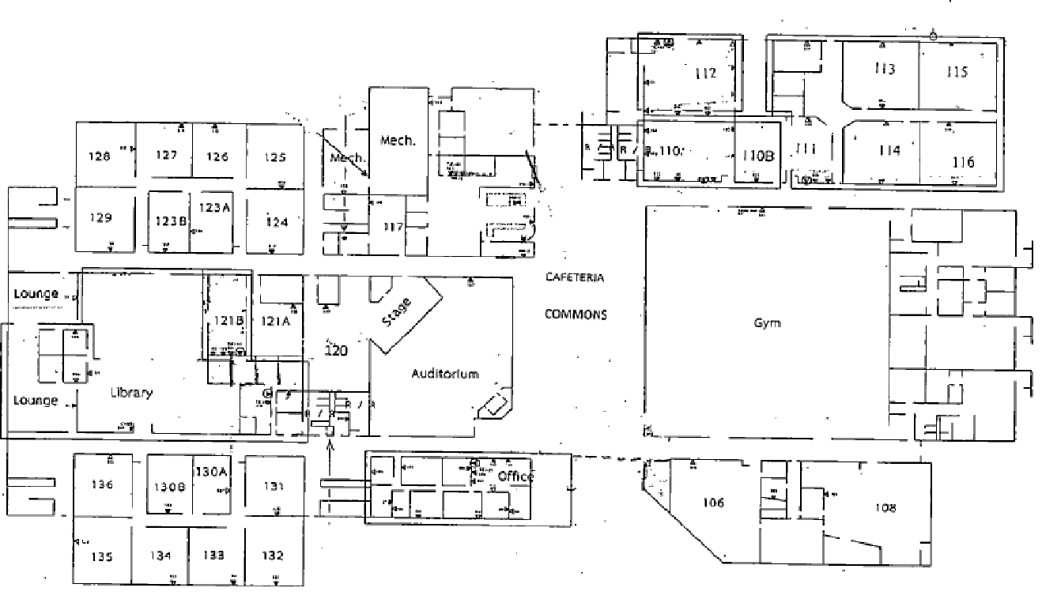

**BRIGGS HIGH SCHOOL MAP**

